

FACILITY

SECONDARY INORMATION CAN GO HERE

ENGAGEMENT

BCHMSA@facilityengagement.ca

LOREUM IPSOM SONAR DELERIT SANTIV EL DANOS

Tios magnatetur, conse quo core, quat archictes estias rem et a core ma dolut quidel ium voluptaqui dollictaquas corem esequis volupta consedi sed magnis ea nimolen dandus ea vellicit estist faccupti consed que ad maximus, ommollam fugia num num de liquid enimaiorio temporerat.

Pudipsa volor ad quod maxim faciet plibus, consequam dicia cuptassequi doluptatem qui ommolum facessit que elligendanis solorep elitio volore dolenis si omnimpo ssincit optusti onsectas necabor roreper atatis ventur re alic to oditem aut quaspitam earum il is volupta dendigent et, quibus aute plit et eiuntia si atiost, sa de dolor aut quo quia sitate venimin ciisti omni beaqui ut am harum net int magnis et ut esed explibe rspero et venim il esequamusam, ium rent eumquam recturi tiorum et duntis doluptin poritemque none pligni nos quo odicienis minvelis alit alit autecab il ma volo conse mo maximusam aperitate parunt qui con renimaior alignat.

Pediciditium et dolore, accuptatur minveriandia volest illestis dolo quia aut od quidel et essus quametum doluptat abo. Minctum fugit ut quunt endigentus cus simi, velitendis maionse quibus et et et venimin tumqui recusci iscidi intuscieni odiasim illibus

WAYS TO GET INVOLVED AND HAVE A SAY

1. Attend our meetings.
2. Join our Working Group.
3. Propose activities for funding.
4. Sign up for email updates (quarterly) at the address below.
5. Give us feedback about our activities.

NAME OF HOSPITAL SOCIETY GOES HERE

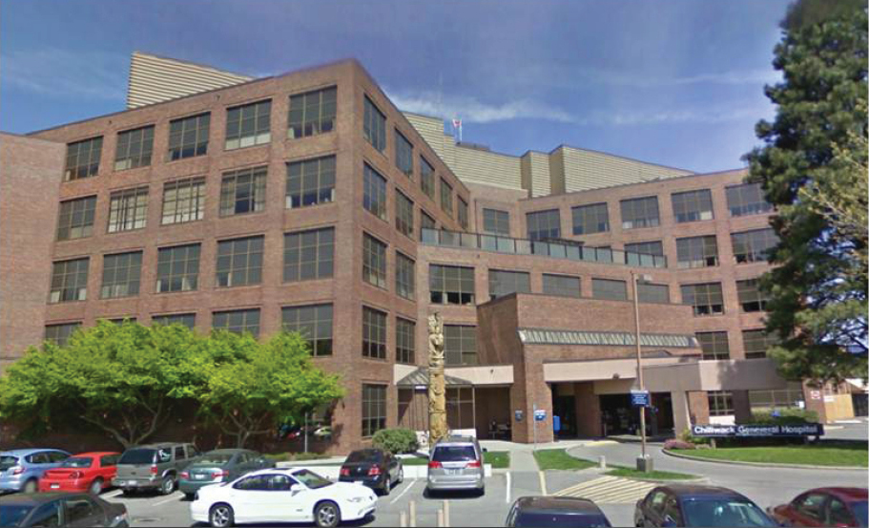

OUR ACTIVITIES

* **Seeking member ideas**
* Loreum ipsom sonar delerit Santic el danos Calibri don active snata itchy con tarall.
* E danos Calibri don active snata itchy con tarall.
* Canas etic al ceranto ipsom.
* **Meeting with health authority and site leadership**
* Loreum ipsom sonar delerit Santic el danos Calibri don active snata itchy con tarall.
* **Current work underway**
* Is maximolorrum et at. Mus, iduci nulliberae dolupta tionsedi dolo tem dolorous nobit hil molorehente officium quodici.
* Dolorrorum nobit hil molorehente officium.
* Mus, iduci nulliberae dolupta tionsedi dolo.

WHO IS INVOLVED?

**Our Physician Society**

> **Dr Jacob A. Apple**, Surgeon, *Director of*

> **Name**, Specialty, *Role*

> **Name**, Specialty, *Role*

> **Name**, Specialty, *Role*

> **Name**, Specialty, *Role*

> **Name**, Specialty, *Role*

WHAT IS FACILITY ENGAGEMENT?

Facility Engagement is a provincial initiative that aims to strengthen working relationships between health authorities and physicians to improve their work environment and the delivery of patient care. It involves:

* **Better opportunities for physicians and health authority leaders to work together** to share knowledge and make informed decisions that can improve patient care, the physician experience, and the cost-effectiveness of the health care system.
* **Opportunities and support for physicians who work at facilities and are members of the medical staff** to have a meaningful voice and increased involvement in local activities that affect their work and patient care.
* **Funding (via the Specialist Services Committee) to support activities that involve physicians in decision making**, and:
  + Pay for physicians’ time in activities.
  + Create a physician society to enable the flow of funds to activities of the medical staff and to hire expertise to support the activities.

Participation is open to all health authorities and facilities with acute care beds, and physicians with privileges inside BC facilities who are members of the medical staff. Membership includes specialists, family physicians, and alternatively paid physicians. An MSA may also choose to have non-physicians participate.

LOREUM IPSOM HOSPITAL

KEY DATES & EVENTS

MAY 15

*Meeting all MSA members*

MAY 15 – JUNE 15

*Proposals accepted for engagement activities*

JULY 1

*Responses to submissions*

JULY 15

*Funds for extended projects*